**Article ID:** [4212] How to load my dishwasher.

**Article name:** How to load my dishwasher

**Topic location:** Dishwasher / Cleaning & Maintenance

Dishwasher / Usage / Poor results

**RFC:**

**Metadata:** filling, dishes

**Related articles:**

**Related questions:**

PNC

DIY

Safety

Link

Email

Book Engineer

Multimedia

Brand

**Article content:**

**WSS**

• Only use the appliance to wash items that are dishwasher safe.

• Do not put items made of wood, horn, aluminium, pewter or copper into the appliance.

• Do not put items that can absorb water (sponges, household cloths) into the appliance.

• Remove remaining food from the items.

• To easily remove remaining burnt food, soak pots and pans in water before you put them in the appliance.

• Put hollow items (cups, glasses and pans) with the opening down.

• Make sure that cutlery and dishes do not bond together. Mix spoons with other cutlery.

• Make sure that glasses do not touch other glasses.

• Put small items in the cutlery basket.

• Put light items in the upper basket. Make sure that they do not move.

• Make sure that the spray arms can move freely before you start a programme.

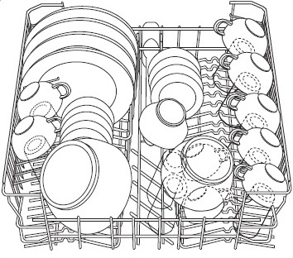 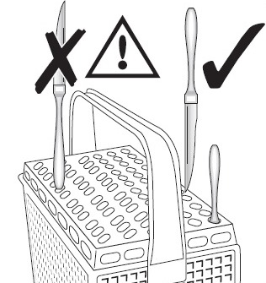

http://services.electrolux-medialibrary.com/bild.php?src=ehppdb-pictures/G/B/JPEG/PSGBDL140G002015.jpg

http://services.electrolux-medialibrary.com/bild.php?src=ehppdb-pictures/G/B/JPEG/PSGBDL140G002016.jpg